This week, I was responsible for doing research on MIDI – specifically, what MIDI is and possibly how it should be applied in the scope of this project. What that meant for me was I had to go look for Python to MIDI packages, as JT’s neural net is based in Python.

The resources I’ve looked up will be listed at the bottom of this entry. I did not read all of them carefully; this is more so I have a bank of things to thoroughly read. These resources consist of pages I’ve found online. I was also provided via email a copy of the MIDI lecture notes given from a class at Cooper Union as well as a suggested page from JT on a Python to MIDI module he considered. Notably, the link he sent specifies a raspberry pi setup, which is the processor we wish to use in the first part of the project, the “box” device. It is imperative to examine if the other pages I’ve found are compatible as I did not account for this when searching for the modules. There SHOULD be little issues as raspberry pi should be perfectly capable of running python libraries.

Regarding MIDI itself, the absolute basics that I’ve noticed in the lecture and all pages is this emphasis that MIDI is not an audio signal. Rather, it is an encoding of all the physical aspects of the synthesizer that result in the sound that plays. How hard and long the key is pressed, what key, and the position of the sliders and knobs are all information stored in MIDI in order to convey to a program what sounds to play out of a speaker.

The MIDI standard is recorded in a very large manual that I’ve saved on my computer and proceeded to not read for the time being because it is, again, very large. However, it does describe all the protocols and this project will probably require us to refer to it at some point moving forward.

MIDI hardware revolves around a large 5-pin connector. Normally only 3 of the pins are used for some reason that I cannot really get at this moment in time. The hardware is standardized, the circuits is provided below. It can also be found on one of the provided links:

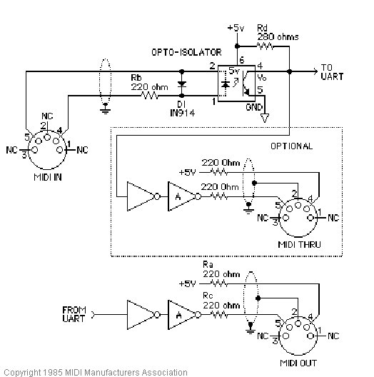

MIDI relies on 3 connections: MIDI IN, MIDI OUT, MIDI Thru. It is somewhat confusing as MIDI IN and MIDI OUT depends entirely on what the device in question is. MIDI OUT from a computer is MIDI IN to a keyboard, example being the computer program sends the MIDI signal to the keyboard so the keyboard can play the right sound. Similarly, MIDI OUT from the keyboard would be sent to the computer as MIDI IN, aka the keyboard sends the MIDI to the computer for the program to process it.

MIDI Thru on keyboards specifically refers to the MIDI data passing in through the keyboard’s MIDI IN. What this means is that the MIDI Thru maintains a direct copy of what goes into the keyboard without affecting what the keyboard can send out from MIDI OUT.